**KWAME NKRUMAH UNIVERSITY OF SCIENCE AND TECHNOLOGY**

**CHEMICAL ENGINEERING DEPARTMENT**

**CHE 158: INTRODUCTION TO INFORMATION TECHNOLOGY**

**INSTRUCTOR:** Dr. (Mrs.) Mizpah A. D. Rockson

LECTURE 5: **SYSTEM SOFTWARE**

**Learning Objectives**

At the end of the lecture the student is expected to be able to do the following:

1. Describe the differences between system software and application software.
2. Identify the four types of system software programs.
3. Explain the basic functions, features, and categories of operating systems.
4. Compare mobile operating systems, including iPhone OS, Android, and Windows Phone.
5. Compare desktop operating systems, including Windows, Mac OS, UNIX, Linux, and virtualization.
6. Explain the purpose of utilities and utility suites.
7. Identify the four most essential utilities.
8. Describe Windows utility programs.
9. Describe device drivers, including Windows' Add a Device Wizard and Update.

**5.0 Introduction**

When most people think about computers, they think about surfing the Web, creating reports, analyzing data, storing information, making presentations, and any number of other valuable applications. We typically think about applications and application software.

We usually do not think about the more mundane and behind-the-scenes computer activities: loading and running programs, coordinating networks that share resources, organizing files, protecting our computers from viruses, performing periodic maintenance to avoid problems, and controlling hardware devices so that they can communicate with one another. Typically, these activities go on behind the scenes without our help.

That is the way it should be, and the way it is, as long as everything is working perfectly. But what if new application programs are not compatible and will not run on our current computer system?

What if we get a computer virus? What if our hard disk fails? What if we buy a new digital video camera and can’t store and edit the images on our computer system? What if our computer starts to run slower and slower?

To effectively use computers, competent end users need to understand the functionality of system software, including operating systems, utility programs, and device drivers.

**5.1 System software**

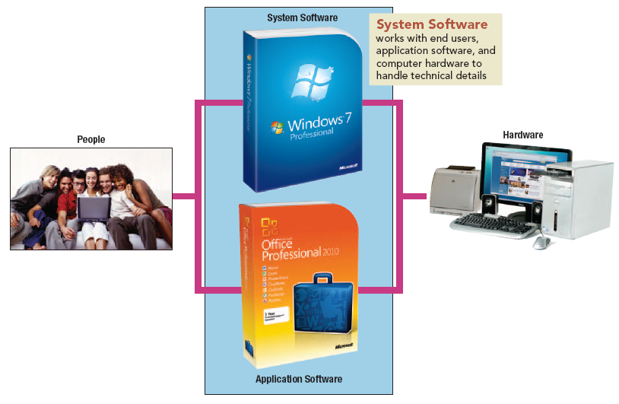

**Figure 5.1: System software handles technical details**

End users use application software to accomplish specific tasks. **System software** works with end users, application software, and computer hardware to handle the majority of technical details. For example, system software controls where a word processing program is stored in memory, how commands are converted so that the system unit can process them, and where a completed document or file is saved.

System software is not a single program. Rather it is a collection or a system of programs that handle hundreds of technical details with little or no user intervention. System software consists of four types of programs:

(1) **Operating systems** coordinate computer resources, provide an interface between users and thecomputer, and run applications.

(2) **Utilities** perform specific tasks related to managing computer resources.

(3) **Device drivers** are specialized programs that allow particular input or output devices to communicate with the rest of the computer system.

(4)  **Language translators** convert the programming instructions written by programmers into a language that computers understand and process.

**5.2 Operating system**

An **operating system** is a collection of programs that handle many of the technical details related to using a computer.

**5.2.1 Functions**

Every computer has an operating system and every operating system performs a variety of functions. These functions can be classified into three groups: managing computer resources, providing a user interface, and running applications.

(1) **Managing resources:** Operating systems coordinate all the computer’s resources including memory, processing, storage, and devices such as printers and monitors. They also monitor system performance, schedule tasks, provide security, and start up the computer.

(2) **Providing user interface:** Operating systems allow users to interact with application programs and computer hardware through a **user interface.** Many older operating systems used a character-based interface in which users communicated with the operating system through written commands such as “Copy A: assign.doc C:”. Almost all newer operating systems use a **graphical user interface (GUI).**

(3**) Running applications:** Operating systems load and run applications such as word processors and spreadsheets. Most operating systems support **multitasking,** or the ability to switch between different applications stored in memory. The program that you are currently working on is described as running in the **foreground.** The other program or programs are running in the **background.**

**5.2.2 Features**

-Starting or restarting a computer is called **booting** the system. There are two ways to boot a computer: a warm boot and a cold boot. A **warm boot** occurs when the computer is already on and you restart it without turning off the power. Starting a computer that has been turned off is called a **cold boot.** During booting, a program called **bootstrap loader** obtains the operating system from the computer hard disk and loads in into memory.

-You typically interact with the operating system through the graphical user interface. Most provide a place, called the **desktop,** which provides access to computer resources. Operating systems have several features in common with application programs, including

* **Icons** —graphic representations for a program, type of file, or function.
* **Pointer** —controlled by a mouse, trackpad, or touchscreen, the pointer changes shape depending upon its current function. For example, when shaped like an arrow, the pointer can be used to select items such as an icon.
* **Windows** —rectangular areas for displaying information and running programs.
* **Menus** —provide a list of options or commands.
* **Tabs**—divide menus into major activity areas.
* **Dialog boxes** —provide information or request input.
* **Help** —provides online assistance for operating system functions and procedures.

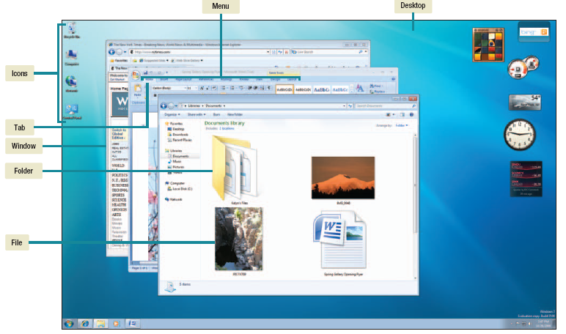

**Figure 5.2: Desktop**

-Most operating systems store data and programs in a system of files and folders. Computer files and folders are stored on a storage device such as your hard disk. **Files** are used to store data and programs. Related files are stored within a **folder,** and for organizational purposes, a folder can contain other folders.

**5.2.3 Categories**

While there are hundreds of different operating systems, there are only three basic categories: embedded, network, or stand-alone.

(1) **Embedded operating systems** are used for handheld devices such assmartphones, cable and satellite television tuner boxes, video game systems,and other small electronics. The entire operating systemis stored within or embedded in the device. The operating system programsare permanently stored on ROM, or read-only memory, chips.

(2) **Network operating systems** are used to control and coordinate computers that are networked or linked together. Network operating systems are typically located on one of the connected computers’ hard disks called the **network** **server.** This computer coordinates all communication between the other computers.

Popular network operating systems include

* NetWare
* Windows Server
* UNIX

(3) **Stand-alone operating systems** also called **desktop** **operating systems,** control a single desktop or notebook computer. These operating systems are located on the computer’s hard disk. When the computer is part of a network, then the desktop operating system works with the network’s NOS to share and coordinate resources. The desktop operating system is then referred to as **client operating system**.

**5.3 Desktop operating systems**

Every microcomputer has an operating system controlling its operations. The most widely used operating systems are **Windows**, **Mac OS**, **Unix**, and **Linux**.

**5.3.1 Windows**

Microsoft’s **Windows** is by far the most popular microcomputer operating system today with nearly 90 percent of the market. Because its market share is so large, more application programs are developed to run under Windows than any other operating system. Windows comes in a variety of different versions and is designed to run with Intel and Intel-compatible microprocessors such as the Core 2 Quad and Atom series.

There are many versions of Windows. The latest, **Windows 8,** was released in 2012 which preceded Windows 7 released in 2009. Older versions are shown in table 5.1.

|  |  |
| --- | --- |
| **Name** | **Description** |
| Windows 98  Windows 2000 Professional  Windows ME  Windows XP  Windows Vista  Windows 7 | Stand-alone operating system.  Upgrade to Windows NT Workstation.  Upgrade to Windows 98 specifically designed for home users.  Upgrade to Windows 2000 with improved interface, stability, and reliability.  Upgrade to Windows XP with improved security, 3-D workspace, and filtering capabilities.  Microsoft’s latest operating system with improved user experience, speed, and stability. |

**Table 5.1: Microsoft desktop operating systems**

Windows gets its name from its use of rectangular boxes called windows.

**5.3.2 Mac OS**

Designed to run with Apple computers, **Mac OS** is not as widely used as the Windows operating system. As a result, fewer application programs have been written for it. Nonetheless, Mac OS is considered to be one of the most innovative operating systems. It is a powerful, easy-to-use operating system that is popular with professional graphic designers, desktop publishers, and many home users.

One of the latest versions of the Macintosh operating system is **Mac OS X.** This operating system provides a wide array of powerful features including Spotlight and Dashboard Widgets. **Spotlight** is an advanced search tool that can rapidly locate files, folders, e-mail messages, addresses, and much more. **Dashboard** **Widgets** are a collection of specialized programs that will constantly update and display information. Some versions of Mac OS X also include **Boot Camp,** which allows Macintosh computers to run both Mac OS and the Windows operating system.

The latest release (November 2014) is Mac OS X v 10.10 called ***Yosemite*** which preceded v 10.9 (June 2013) called ***Mavericks***.

**5.3.3 UNIX and Linux**

The **UNIX** operating system was originally designed to run on minicomputers in network environments. Now, it is also used by powerful microcomputers and by servers on the Web. There is UNIX standard. This means that an application written for one version of UNIX may not run on other version.

Linux is a version of UNIX receiving a great deal of attention. Linux was originally developed by a graduate student at the University of Helsinki, **Linus Torvalds**, in 1991. He allowed free distribution of the operating system code and encouraged others to modify and further develop the code. Programs released in this way are called **open source.** Linux has been the basis of several other operating systems. For example, **Google’s** **Chrome OS** is based on Linux. This operating system is designed for netbook computers and focuses on Internet connectivity through cloud computing.

**5.3.3 Virtualization**

Virtualization is the ability of a single microcomputer to run 2 or more applications requiring different operating systems.

With **virtualization software,** the physical machine can be logically separated into separate and independent virtual computers known as **virtual** **machines.** Each virtual machine appears to the user as a separate independent computer with its own operating system. The operating system of the physical machine is known as the **host operating system.** The operating system for each virtual machine is known as the **guest operating** **system.**

**5.4 Mobile phone operating systems**

**Mobile phone operating systems,** also known as **mobile OS,** are a typeof embedded operating system. Everysmartphone has a mobile phone operatingsystem.

While there are numerous mobile phone operating systems, some of the best known are **Symbian**, **BlackBerry OS**, **iPhone OS**, **Android**, and **Windows Phone 7**.

* **Symbian** has its origins in Japan with Nokia, Sony, and others. Introduced in 2009, it controls more smartphones worldwide than any other mobile operating system before the end of 2010.
* **BlackBerry OS,** also known as **RIM OS,** was first introduced in 1999 by a small Canadian firm called Research In Motion. Originally designed as the platform for the BlackBerry handheld computer, it has evolved into a powerful mobile phone operating system that is challenging Symbian.
* **iPhone OS** was originally developed in 2007 by Apple. It is based on Mac OS and is used as the platform for Apple’s iPhone, iPod Touch, and iPad. iPhone OS is one of the fastest growing mobile operating systems.
* **Android** was originally introduced in 2007. It was originally developed by Android Inc. and later purchased by Google. As of early 2015, Android controls more smartphones worldwide than any other mobile operating system.
* **Windows Phone 7** was introduced in 2010. It followed two other mobile operating systems from Microsoft: **Windows CE** and **Windows Mobile**. Windows Phone 7 was designed for users actively involved in social networking and instant messaging.

**5.5 Utilities**

Ideally, microcomputers would continuously run without problems. However, that simply is not the case. All kinds of things can happen—internal hard disks can crash, computers can freeze up, operations can slow down, and so on. These events can make computing very frustrating. That’s where utilities come in. **Utilities** are specialized programs designed to make computing easier. There are hundreds of different utility programs. The most essential are:

* **Troubleshooting** or **diagnostic programs** that recognize and correct problems, ideally before they become serious.
* **Antivirus programs** that guard your computer system against viruses or other damaging programs that can invade your computer system.
* **Uninstall programs** that allow you to safely and completely remove unneeded programs and related files from your hard disk.
* **Backup programs** that make copies of files to be used in case the originals are lost or damaged.
* **File compression programs** that reduce the size of files so they require less storage space and can be sent more efficiently over the Internet.

Most operating systems provide some utility programs. Even more powerful utility programs can be purchased separately or in utility suites.

**5.5.1 Windows utility**

The Windows operating systems are accompanied by several utility programs, including Backup and Restore, Disk Cleanup, and Disk Defragmenter.

**Backup and Restore** is a utility program included with the many versions of Windows that makes a copy of all files or selected files that have been saved onto a disk. It helps to protect you from the effects of a disk failure.

When you surf the Web, a variety of programs and files are saved on your hard disk. Many of these and other files are not essential. **Disk Cleanup** is a troubleshooting utility that identifies and eliminates nonessential files. This frees up valuable disk space and improves system performance.

**Disk Defragmenter** is a utility program that locates and eliminates unnecessary fragments and rearranges files and unused disk space to optimize operations.

**5.5.2 Utility suites**

Some of the well known utility suites are:

* **Norton 360** It includes the following: **Norton AntiVirus**, **Norton CleanSweep** (for safe removing of programs and files you no longer need. It will archive, move, and make backups of programs as well as clean up the hard disk) and GoBack Personal Edition (will restore system configuration, locate lost files, and repair damaged files)
* **McAfee Office**
* **V Communication SystemSuite**

**5.6 Device drivers**

Every device, such as a mouse or printer that is connected to a computer system has a special program associated with it. This program, called a **device driver** or simply a **driver,** works with the operating system to allow communication between the device and the rest of the computer system.

Each time the computer system is started, the operating system loads all of the device drivers into memory. Whenever a new device is added to a computer system, a new device driver must be installed before the device can be used.

Windows supplies hundreds of different device drivers with its system software. For many devices, the appropriate drivers are automatically selected and installed when the device is first connected to the computer system. For others, the device driver must be manually installed.

If a particular device driver is not included with the Windows system software, the product’s manufacturer will supply one. Many times these drivers are available directly from the manufacturer’s Web site.

When your computer behaves unpredictably, you may reinstall or update your device drivers to solve the problem.